UNX511: Lab1 Professor: Shahdad

/****************************************************************************** ***
  - UNX511-Lab1
  - I declare that this lab is my own work in accordance with Seneca Academic Policy.
  - No part of this assignment has been copied manually or electronically from any other source * (including web sites) or distributed to other students.
*
  - Name: Lebna Noori Student ID: 157672205 Date: 2025-05-12
*
******************************************************************************
**/

UNX511 Lab 1: Monitoring Process Memory Usage Due: Sunday, May 18, 2025 (11:59pm)
- Explain the difference between virtual memory and resident memory. What is virtual memory? What is resident memory?
  - Virtual Memory (VmSize) is the total memory the process can access, including code, data, and shared libraries. Includes parts not currently in RAM. Resident Memory (VmRSS) is portion of memory currently in RAM. This is the physical memory that’s actually being used. Overall virtual memory is the total "possible" memory mapped, while resident memory is the actual memory being used in RAM

- Research and report on any of the three of the processes returned by your program. Simply explain what these processes do.
  - PID: 254, Name: unattended-upgr, VmRSS: 22380 kB
    - What it does:
unattended-upgrades is a daemon that automatically installs security updates and other package updates on Debian-based systems (like Ubuntu). It's part of the unattended-upgrades package, which helps ensure your system stays secure by keeping software up to date without manual intervention.
    - Common Use:
Automatically installs security patches.
Can be configured to remove unused dependencies or notify admins.
    - Impact:
Helpful on servers and desktops to reduce maintenance burden and minimize vulnerabilities.
  - PID: 1744, Name: packagekitd, VmRSS: 20600 kB
    - What it does:
packagekitd is the daemon part of PackageKit, a system service that provides a unified way to manage software packages across different package managers (like APT, DNF, or Zypper). It enables GUI tools (like GNOME Software) to install, update, or remove software.

    - Common Use:
Allows software managers to work independently of the underlying package system.
Used heavily in desktop environments.
    - Impact:
Makes it easier for users and applications to manage software without directly using the command line.
  - PID: 51, Name: systemd-journal, VmRSS: 17412 kB
    - What it does:
systemd-journald is the system logging service used by systemd. It collects and manages logs from the kernel, system services, and applications. These logs are stored in binary format and accessed using the journalctl command.
    - Common Use:
Centralized logging.
Structured log entries with metadata.
Important for debugging and auditing.
    - Impact:
Essential system service that replaces older logging systems like rsyslog in many Linux distros.

- Output of my script
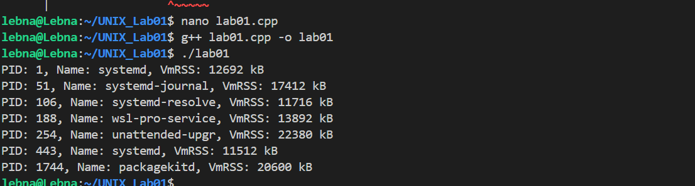
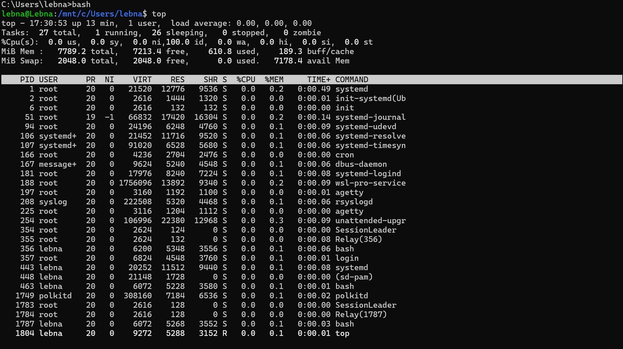
- Top command in bash

